What does ClusterIP, NodePort, and LoadBalancer mean?  
  
In kubernetes a service always enables its network access to a pod or set of pods.  
  
The type property in the Service's spec determines how the service is exposed to the network. The possibles are ClusterIP, NodePort, and LoadBalancer  
  
ClusterIP – The default value. The service is only accessible from within the Kubernetes cluster  
NodePort – This makes the service accessible on a static port on each Node in the cluster.  
LoadBalancer – The service becomes accessible externally through a cloud provider's load balancer functionality. GCP, AWS, Azure, and OpenStack offer this functionality.  
Ingress - The Ingress concept lets you map traffic to different backends based on rules you define via the Kubernetes API

Activate to view larger image,

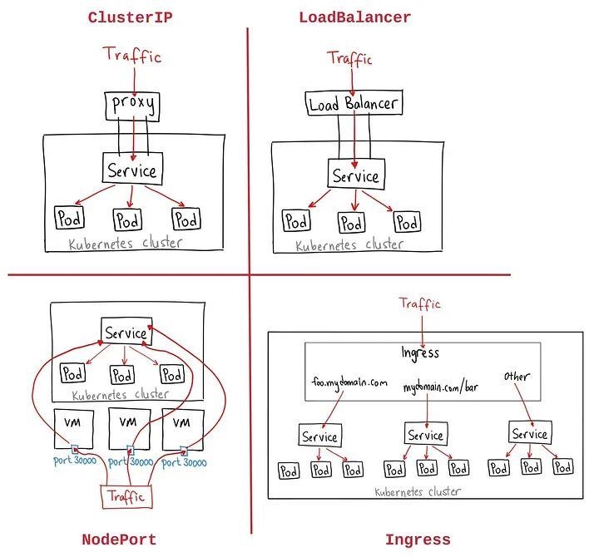

Activate to view larger image,